Lab Safety
Objectives:
- To review and sign the safety contract by both student and parent/guardian.
- To know the location and use of the safety equipment located in the science room.
- To utilize science safety rules in order to make good decisions concerning safety in the science room.
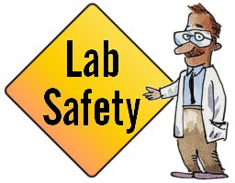
Task Completion:
Complete all:
- View online safety ppt (Lab Safety 2) and complete accompanying worksheet.
- Review and sign safety contract and have a parent also review and sign.
- Draw a safety equipment floor plan.
- Pass the safety quiz with no less than a 75% (Quiz will be retaken until passed).

Complete 2:
- Safety scenarios match; lay out the scenario and rule cards. Match to the scenario every rule that is being broken. Record on the worksheet. Repeat with all scenarios.
- Safety crossword worksheet
- Equipment Taboo to be played with no more than 4 students at a time. Make a new taboo card for one of the safety rules.
- Laboratory Clue to be played with no more than 4 students at a time. When finished use the clue cards to write a scenario.

Complete 2:
- Skits - Choose a group of no more than 5 students. Get a scene from the teacher. Prepare the skit for acting out. Be sure to include props. Your teacher can assist with some science equipment and you can bring props from home. EVERYONE must actively participate in the skit. This may mean adding parts.
- Article – Read an article concerning safety in the lab. Write a two paragraph summary of the article. The first paragraph should state the who, what, when, where, and why of the problem. The second paragraph should be your opinion as to what may have been done to prevent the problem.
- Home Scenarios – Come up with two situations at home where safety could be an issue. Describe each in a scenario with characters, what happened, how did the characters react, and what they should have done differently.
- Video Scenes - Recreate one of the safety rules into a video clip. The clip should be semiprofessional using props and acting techniques.

