Name_______________
Class_______ No.____
Date_________________
Lab Safety Worksheet 2
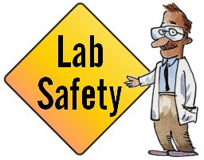
What’s Wrong with picture1? Identify 6 things wrong in picture 1
___________________________________ ________________________________
___________________________________ ________________________________
___________________________________ ________________________________
What’s Wrong with picture 2? Identify 3 unsafe activities and tell why each is unsafe.
___________________________________ ________________________________
___________________________________ ________________________________
___________________________________ ________________________________
What’s Wrong with picture 3? Identify 3 unsafe activities and tell why each is unsafe.
___________________________________ ________________________________
___________________________________ ________________________________
___________________________________ ________________________________

What should you do if…

- Your clothes catch on fire?________________________________________
- Chemicals spill on your hand?_______________________________________
- You get a particle in your eye______________________________________
What is the #1 priority in the Science room? ______________________________
Who is responsible for lab safety? _______________________________________

