Science Binder/Notebook
8th grade
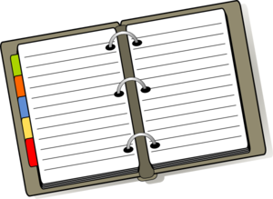
Your Science Binder/ Notebook is to help you STAY ORGANIZED!
- Your Binder/Notebook should have a Table of Contents.
Date | Title | Page
Ecology Unit
9/12/14 | Oh Deer Reflection | Journal 12
- You may use any system you want, but when I check your work I need to be able to find it.
- You may use labeled divisions (if choosing a notebook, divide the notebook with tabs) and start renumbering for each section
  - Journal
  - Vocab/Notes
  - Activities
  - Experiments
  - Homework
Or you may just keep numbering consecutively and not use divisions.
- You need a folder to hold papers (pockets in each section would be helpful to organize.) until they get punched or glued into each section. I will need papers attached in some way when it is turned in.
- There needs to be paper in your binder/notebook.
- Again, I WILL periodically collect and check your Binder/Notebook. Keep it neat and organized. Use the last few minutes of class once a week to do this. No other subject papers in it. Papers should have titles of activity, date, and page number.
Activities
mework/Daily

Journal
mework/Daily

Homework
mework/Daily

Experiments
mework/Daily

Vocab/Notes
mework/Daily

